Monarch | Length of Reign | Number of Heretics Executed
Henry VII | 24 years | 10
Henry VIII | 38 years | 81
Edward VI | 6 years | 2
Mary I | 5 years | 284
Elizabeth I | 45 years | 5
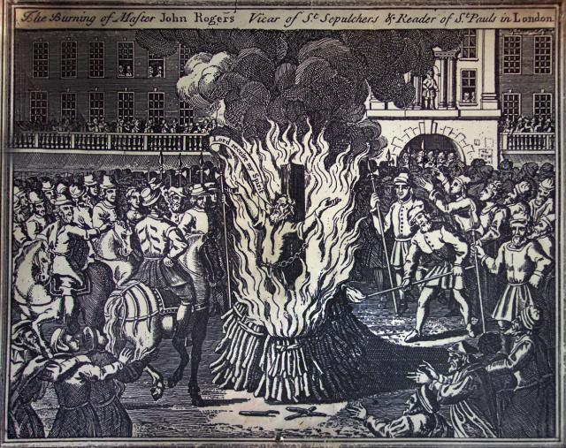
In 1554 Mary crushed a rebellion led by Sir Thomas Wyatt. Making the most of her advantage, she married Philip, pressed on with the restoration of Catholicism and revived the laws against heresy. Over the next three years, hundreds of Protestants were burned at the stake. This provoked disillusionment with Mary, deepened by an unsuccessful war against France which led to the loss of Calais, England's last possession in France, in January 1558. Childless, sick and deserted by Philip, Mary died on 17 November 1558. Her hopes for a Catholic England died with her.
Painting of the burning of John Rogers, the first religious martyr burnt in 1555. Rogers translated the Bible into English.
English people, at this time, feared the power of Spain. To bring the two countries closer together, Mary accepted a marriage proposal from the king of Spain - Philip II. He was also a very strong Catholic. Mary’s advisors and friends warned her not to marry Philip but she went against their advice and married him in 1554. The people of England greatly feared that Philip would control England and this lead to Mary becoming very unpopular with her people.

“All the people of London rejoiced and made many great fires. They set out tables and feasted. The bells rang till ten of the clock at night”
– From a letter written at the time of Mary’s accession (crowned queen).

Mary I was queen from 1553 to 1558. When she was crowned queen, she was very popular with the people of England. It was this popularity that helped to quickly overturn the attempt to put Lady Jane Grey onto the throne of England.
Mary completely reversed the religious changes of Edward. She had been brought up as a strict Roman Catholic and was horrified by her half-brother’s changes. The Catholic Mass was restored and Holy Communion was banned. All priests had to be Catholic; the basic furniture in the Protestant churches was replaced with the colourful furniture and paintings of the Catholic Church. Services were held in Latin and Cranmer’s English prayer book was banned. The pope was made head of the church again. The majority of the people of England accepted these changes - the Tudor royal family was still respected throughout the country. However, some did not. Some refused to change and they were burned at the stake for heresy.

