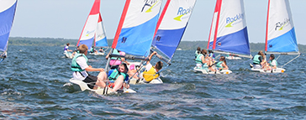

Rockley Adventure

Information Booklet for Parents



Welcome to Rockley
Introduction
Rockley is a family run business established in 1976, run by husband and wife team, Peter and Lis Gordon. Peter and Lis are assisted by some of the most experienced and qualified watersports staff in the country! They pride themselves on having created sailing centres based in some of the most beautiful parts of Europe and their aim is always to offer outstanding training and family holiday experiences.
Our enthusiasm for all things outdoor is what underpins the success of our highly regarded, residential watersports trips for schools and groups of young people. Our aim is simple, “To deliver the best possible service to group leaders, participants and their parents, throughout the booking, delivery and review of their trip!”

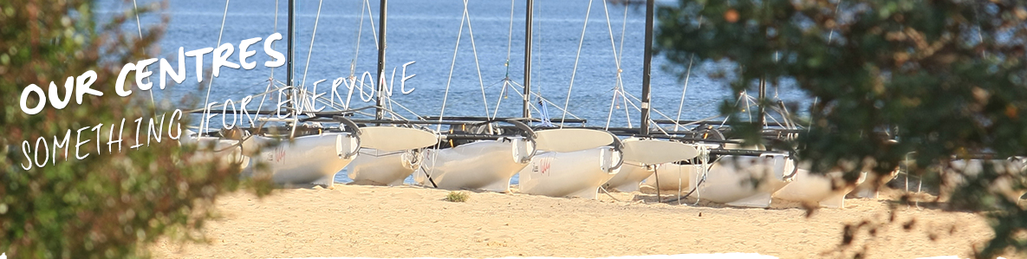

Staff
Rockley’s excellent instructors are chosen for their combination of qualifications, experience, patience and good humour. They are very aware of the safety standards and possess a great ability to work and communicate effectively with youngsters and adults. All activities will be delivered by an enthusiastic, passionate team of qualified experts.
All staff are qualified to the relevant National Governing Bodies and are CRB checked.
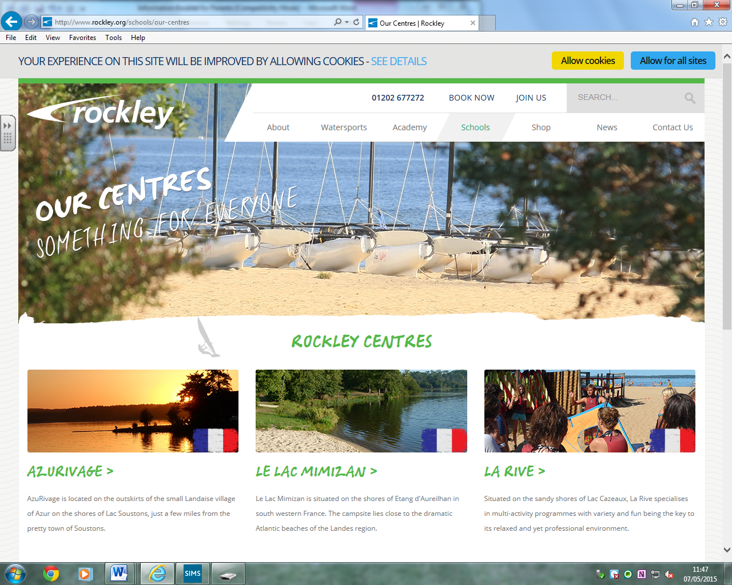

Arriving in Le Lac, Mimizan.
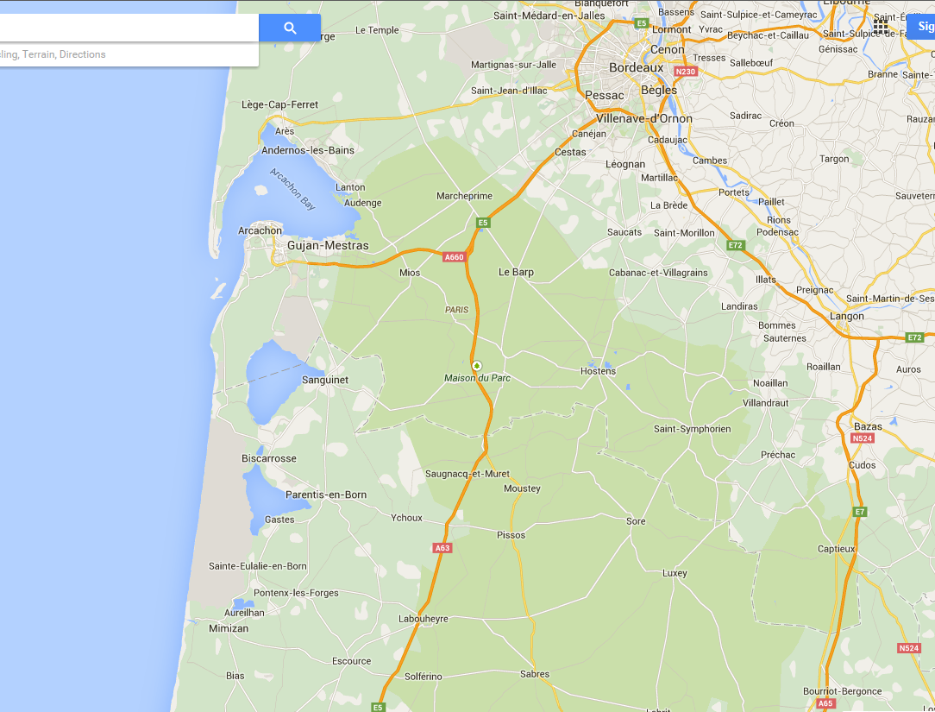
Rockley, Le Lac, Mimizan
The comprehensive range of equipment at Le Lac caters for a wide range of abilities and ages and Le Lac Mimizan’s location makes it the perfect choice for groups looking for a mix of land and water-based activities. Le Lac Mimizan is our newest centre in France and, just like our other French centres, is based on a campsite on the shores of a fresh water lake close to the dramatic Atlantic beaches of the Landes region.
Our watersports activities launch directly onto the lake and the sheltered location provides an ideal introduction to our range of watersports activities from dinghy sailing to paddle boarding. It also provides the opportunity to explore the shoreline of Château Woolsack or land for lunch at a quiet, unspoilt beach.
Departure Day
Departure from Cranborne Middle school is on Saturday 23rd June 2018 at 1.00pm. Aim to arrive at school no later than 12.30pm. Please make sure that your luggage, sleeping bag, pillow and any medication is clearly labelled with your child’s name.
Return arrival is approximately 1.30pm on Saturday 30th June 2018. We will start the phone tree (which will be issued nearer the time) when we are approximately an hour or two away.

When we arrive at Le Lac, we will be greeted by ‘The Team’. We will be given a tour of the centre which will include information regarding fire procedures and the health and safety policy.

What to expect from your weekly programme (sample programme/may change):
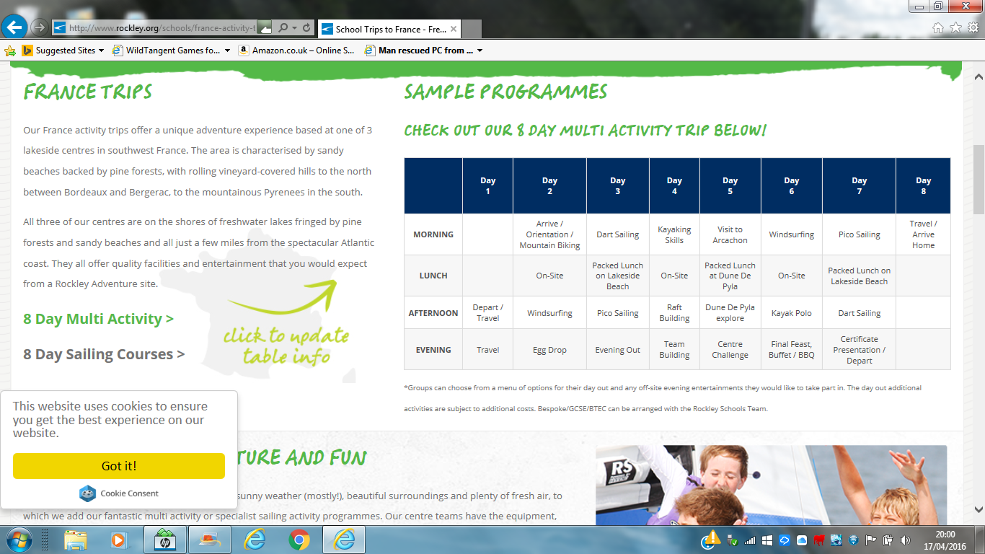

Rockley envisage operating your programme as scheduled. Changes to programmes may sometimes be necessary due to weather conditions and other factors affecting the safe operation of various activities. Rockley reserve the right to make such changes to ensure the maximum safety and enjoyment for all.

What do you need to bring?
Recommended Kit List (all is essential)
- Your CMS school sweatshirt (this MUST be in your rucksack and worn on the ferry)
- Lightweight Waterproof Jacket (for the occasional shower & evenings)
- Wet Shoes/trainers for Sailing.
Footwear such as ‘crocs’ and flip flops are considered dangerous and will not be permitted.
- Strong sensible shoes/trainers for land based activities.
- Long sleeved top & tracksuit trousers / jogging bottoms / combat trousers.
- T-shirts x 7
- Rash vest (recommended)
- Sweatshirt / jumper
- Shorts (3 or 4 pairs NOT denim!); jeans / long trousers
- Swimming costume or trunk/shorts.
- Pyjamas / nightwear
- Underwear (enough for every day); socks (in case evenings are chilly)
- Bedding: Sleeping bag, pillow & pillowcase.
- Towels (1 beach towel and 1 bath towel)
- Wash kit, soap, shampoo, etc.
- Small torch (and batteries!)

- Large sturdy plastic bag / binbag (For your damp / dirty clothes)
- Waterproof Sun Cream (ideally factor 50)
- Small rucksack or bag (for on the coach / ferry / day trip)
- Named Drinking water bottle (essential)
- Sunglasses & sun hat

If pupils possess a shortie wetsuit, they can bring this instead of wearing shorts and t-shirt/rash vest, but it is not essential.
What should you not bring?
- Specialist safety equipment such as buoyancy aids and helmets are provided for you.
- NO valuables & NO mobile phones
- Expensive personal property.
- NO electrical items (hairdryers / hair straighteners / games consoles etc)

Nb: It is advisable to use a soft bag/holdall if possible to pack your belongings. It is easier for the coach driver when packing the coach.
Facilities at Le Lac.
- Based on the shores of Étang d’Aureilhan
- Located close to the beautiful seaside town of Mimizan Plage
- Quiet and relaxed, away from the hubhub of larger sites
- Rockley has its own, secure area, a stones throw away from the lake
- Chalet style tents arranged into ‘villages’ that include: electric light, metal framed beds, mattresses, curtains and, for added safety, a personal alarm.
- Table tennis, boules court, beach volleyball pitch
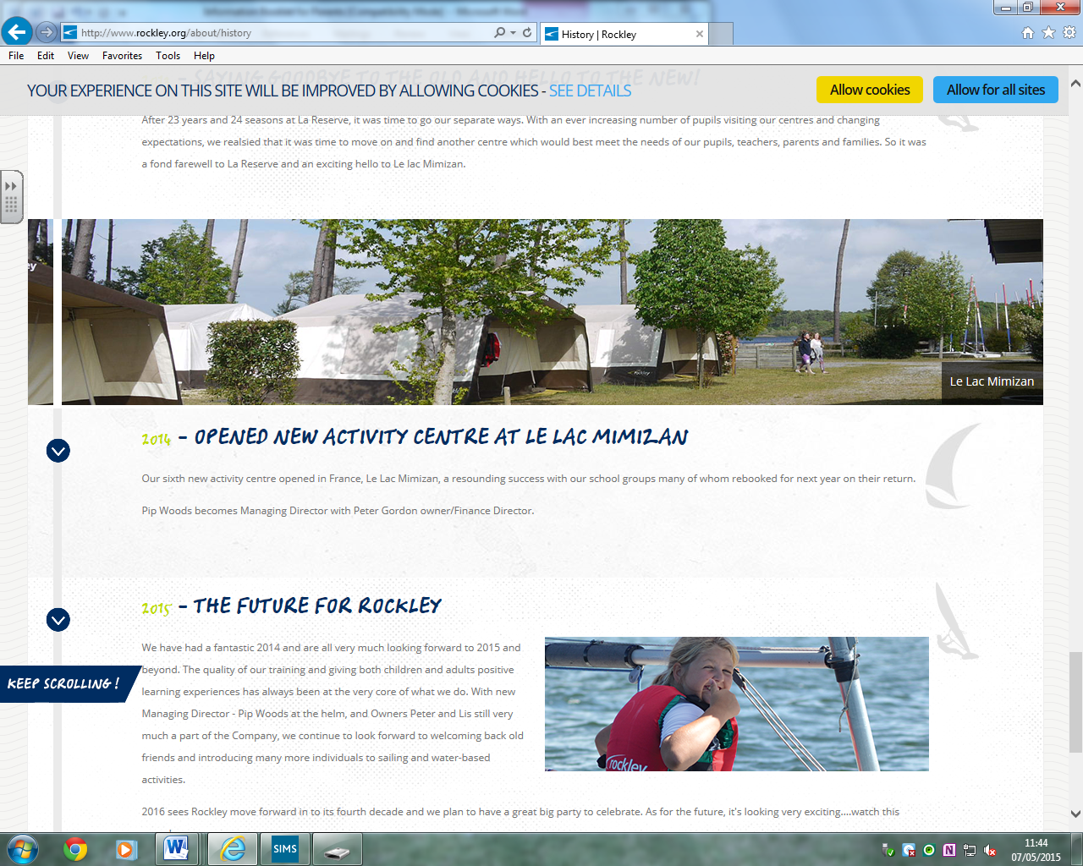
Food and refreshments
Our meal times are an important social aspect of the trip and in France, our 'al fresco' dining area makes a positive contribution to the whole trip experience. Our wonderful team provide three home cooked, healthy, balanced meals per day and cater for special requirements such as vegetarian, gluten free, dairy intolerant etc.
Meal Times
Breakfast 8:00am to 8:30am

(Cereals, such as rice pops, honey pops, muesli, oat bran and bran flakes with apple or orange juice, tea, coffee, hot chocolate or milk and fresh baguettes with jam, honey and marmite.)

Lunch 12:30pm to 1:30pm

(Buffet selection of cold meats, cheeses, fish, salad, pasta, rice, potatoes and dressings with a choice of yoghurts, cakes and pastries or fresh fruit.)

Dinner 6:00pm to 6:30pm

(A choice of two dishes of meat, fish or a vegetarian option (for specified vegetarians only). Dishes such as Lasagne, Tagliatelle, Curries, Casserole with vegetables. Light desserts including yoghurts and fresh fruit.)
Essential information for you and your child.

Some basic rules and expectations.
- Any areas marked ‘Staff only’, ‘Private’ or ‘No admittance’ are out of bounds to all students.
- Access to the lake area is only permitted when accompanied by a Rockley member of staff.
- Suitable footwear must be worn at all times.
- Use or possession of illegal substances is strictly forbidden.
- Teachers and group leaders are only expected to enter tents which are occupied with their own students.
- No student should enter any tent other than their own.
- Tents are cleaned weekly and will be presented in a clean, tidy and graffiti free condition. We expect them to remain in the same condition during your stay. Tents will be checked on the day of departure.
- We will not tolerate any kind of damage to the tents. Any costs incurred to repair such damages will be the responsibility of the teachers and group leaders.
- All public areas are cleaned regularly by our staff. We do expect these areas to be kept clean and tidy after usage.
- All rubbish needs to be disposed of in the correct manner in the waste bins provided.
- No Food or drink can be taken into the tents.
- Noise must be kept to a minimum especially between the hours of 10:00pm and 7:00am.

Centre details

Address: Rockley Adventure
Camping Du Lac
108 Avenue de Woolsack
F-40200
Mimizan, Landes
France
Centre Manager: Kate Murphy

Important Documents
There are a number of important documents that you need to be aware of before the trip commences. Copies are available within school for you to look at should you wish to. They are also available to view on our school website and / or the Rockley website:
- Risk Assessments for all of our activities.
- Public and product liability Insurance Document.
- Example Kit List

Cranborne Middle School Staff who will be on the trip.
Mrs Williams Trip Leader – First aider
Mr Phelps
Mr Greetham
Miss Clasby

What information do we need from you?
- Any change of address or phone number MUST be passed on to the school so we can update our emergency contact details.
- Your consent form if you have not already completed it.
- Your child’s passport and EHIC card if you have not already brought them in to school to be copied.
- Any updates on any medical conditions or medication required that would not have been brought to my attention when completing the original consent form.

